CST 415 – Lecture 9
Wilsonville, Fall 2017

Mail
CNP 3.2.2, Pg. 37-46

Mail includes several protocols useful for delivering messages

Consider the following example where Alice and Bob are exchanging email…
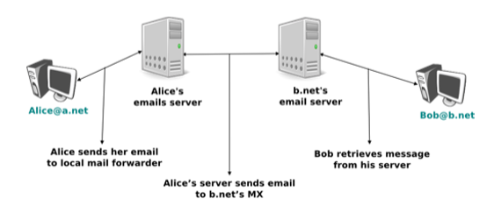
There are four crucial parts to make this work…
- Mail message format that is common across all clients/servers
- Mail protocols that allow clients/servers to talk with each other
- Mail client programs, used by both Alice and Bob to send/receive email
- Mail server programs, exchanging emails on Alice’s and Bob’s behalf

Email messages come in two parts: header and body, separated by a blank line

Email Header made up of text lines with labels and values:
From:
Date:
To:
cc:
bcc:
Subject:

Other optional header lines can help the clients and servers to track the message and put it into conext, e.g.
Message-Id:
In-reply-to:
Received:

The body of the email can be just ASCII text, or it can be a specific type of content
Remember MIME?
We can use these headers…
MIME-Version:
Content-Type:
Content-Transfer-Encoding:

SMTP – Simple Mail Transfer Protocol
Protocol used for sending email from client to server and server to server

The email client is configured with the address of the first hop SMTP server
Each SMTP server hop requires a DNS lookup for MX entries (Mail eXchange)

SMTP defines the following types of applications:
MUA – Mail User Agent
MSA – Mail Submission Agent
MTA – Mail Transmission Agent
MDA – Mail Delivery Agent

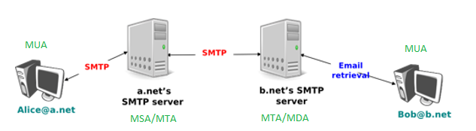

SMTP is used from MUA, through MSA and a series of MTA, until it arrives at an MDA
POP or IMAP are used by the receipient’s MUA to retrieve email from the MDA (below)

SMTP is over TCP/IP and is a text based, line oriented protocol

Requests…
HELO – want to send some mail
MAIL FROM – hereis the sender of the mail
RCPT TO – here is the recipient of the mail
DATA – ready to send mail data
QUIT – done sending mail data

Responses are a 3-digit code, followed by optional text, e.g.
2xy – success
3xy – success, but more information required
4xy – transient failure, try again later
5xy – permanent failure
Example responses:
250 Requested mail action okay, complete
354 Start mail input; end with <CRLF>.<CRLF>
452 Requested action not taken: insufficient system storage
500 Syntax error, command unrecognized

POP – Post Office Protocol
Protocol used to connect to an MDA and retrieve email waiting for recipient
Text based and line oreinted, over TCP

Three phases:
- Authorization
- Transaction
- Update

To authorize, the client sends username/password using USER/PASS commands

Transactions include…
STAT – retrieve status of the server, including # of messages and size of mailbox
RETR – retrieve a specific message from the mailbox
DELE – mark a specific message in the mailbox for deletion
QUIT – done with transations

Responses include “+OK” or “-ERR” to indicate success/failure of any commands

During the update phase, the server deletes any messages marked for deletion

IMAP – Internet Message Access Protocol
Similar to POP, but allows orgaization in folders, deletion and searching

File Transfer
ICN 11.3 Pg. 282

TFTP – Trivial File Transfer Protocol
A simple protocol for requesting or sending a file using datagrams over UDP

There are 5 packet types exchanged between client and server:
RRQ – Read request for a specified file
WRQ – Write request for a specified file
DATA – A block of file data
ACK – Acknowledge a block of file data
ERROR – Error response for any request or data

When a client connects to the server, it starts with an RRQ or a WRQ
The server immediately allocates a new UDP port and socket and replies on that port
The client switches to the new port for the remainder of the conversation
This port switching allows the server to simplify it’s structure and keep clients segregated

Data blocks are numbered from 1 to N, the last block
Blocks are in 512 byte chunks
Each DATA packet includes the 16-bit block number along with the data
ACK packets include just the 16-bit block number

The sender of a file sends a single DATA packet with block number and data, then waits
The receiver sends a single ACK with the same block number, then waits
The sender confirms block numbers then sends the next DATA packet
In this way, data is received exactly in order

The receiver can send an ERROR, which generally causes termination of the connection

Using UDP, there are a number of scenarios that must be dealth with…

DATA lost… file sender retransmits DATA after timeout
DATA delayed… file receiver throws away out of sequence DATA blocks
DATA duplicated… file receier throws away duplicate DATA blocks
ACK lost… file sender waits then retransmits DATA after timeout
ACK delayed… file sender throws away ACKs that are out of sequence
ACK duplicated… file sender throws awa duplicate ACKs

More troubling is RRQ/WRQ delayed, which can result in a duplicate connection request when the client resends the same file request. TFTP handles this by expecting the client to drop one of the server responses, in case it responds twice, on different sockets.

Throughput is limited with the Stop-and-Wait of DATA/ACK
Solution is to use a sliding window, as in TCP

